Enterprise Network Project Report
Project Title: Build a Simple Enterprise Network Using OSPF with VLANs, DHCP, DNS, and Web Server
Prepared By: Shruti Thapa

Introduction
This project demonstrates the design and implementation of a simple enterprise network with two routers connected using OSPF. The network is segmented into VLANs for different departments and uses Router-on-a-Stick for inter-VLAN routing. DHCP is implemented for automatic IP assignment, and a server provides DNS and web services. The project also emphasizes systematic troubleshooting.
Objectives:
- Configure VLANs for different departments
- Setup inter-VLAN routing using router-on-a-stick
- Configure DHCP with scopes
- Add DNS and web server
- Verify OSPF routing and network connectivity
- Practice systematic troubleshooting

Network Requirements
Devices:
Device | Model | Quantity
Router | Cisco 2911 | 2
Switch | Cisco 2960 | 2
PC | Generic | 4
Server | Generic | 1

Cables:
Connection | Cable Type
PC → Switch | Copper Straight-Through
Switch → Router | Copper Straight-Through
Router → Router | Serial DCE/DTE
Server → Switch | Copper Straight-Through

Network Topology
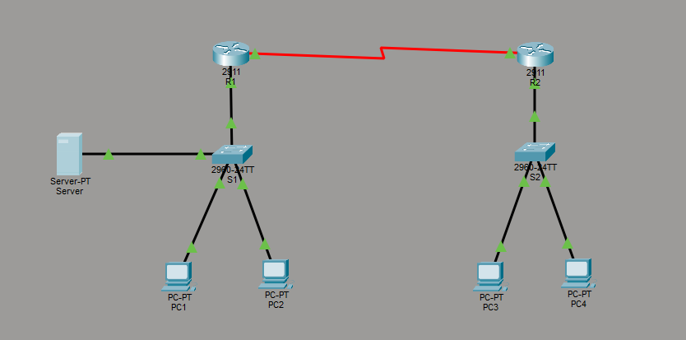

IP Addressing Plan
Device/Interface | IP Address | Subnet Mask | VLAN / Network
R1 G0/0.10 | 192.168.10.1 | 255.255.255.0 | VLAN 10 (HR)
R1 G0/0.20 | 192.168.20.1 | 255.255.255.0 | VLAN 20 (IT)
R2 G0/0.10 | 192.168.10.2 | 255.255.255.0 | VLAN 10 (HR)
R2 G0/0.20 | 192.168.20.2 | 255.255.255.0 | VLAN 20 (IT)
R1 S0/0/0 | 10.0.0.1 | 255.255.255.252 | Router Link
R2 S0/0/0 | 10.0.0.2 | 255.255.255.252 | Router Link
Server | 192.168.10.100 | 255.255.255.0 | VLAN10
PC1, PC3 (HR) | DHCP assigned | 255.255.255.0 | VLAN10
PC2, PC4 (IT) | DHCP assigned | 255.255.255.0 | VLAN20

Configuration Steps

Configure VLANs on Switches
S1:
enable
configure terminal
vlan 10
name HR
vlan 20
name IT
interface fa0/1
switchport mode access
switchport access vlan 10
interface fa0/2
switchport mode access
switchport access vlan 20
interface fa0/24
switchport mode trunk
end
S2:
enable
configure terminal
vlan 10
name HR
vlan 20
name IT
interface fa0/1
switchport mode access
switchport access vlan 10
interface fa0/2
switchport mode access
switchport access vlan 20
interface fa0/24
switchport mode trunk
end

Router-on-a-Stick Configuration
R1:
enable
configure terminal
interface g0/0
no shutdown
interface g0/0.10
encapsulation dot1Q 10
ip address 192.168.10.1 255.255.255.0
interface g0/0.20
encapsulation dot1Q 20
ip address 192.168.20.1 255.255.255.0
end
R2:
enable
configure terminal
interface g0/0
no shutdown
interface g0/0.10
encapsulation dot1Q 10
ip address 192.168.10.2 255.255.255.0
interface g0/0.20
encapsulation dot1Q 20
ip address 192.168.20.2 255.255.255.0
end

Configure Serial Link Between Routers
R1:
interface s0/0/0
ip address 10.0.0.1 255.255.255.252
clock rate 64000
no shutdown
R2:
interface s0/0/0
ip address 10.0.0.2 255.255.255.252
no shutdown

Configure OSPF Routing
R1:
router ospf 1
network 192.168.10.0 0.0.0.255 area 0
network 192.168.20.0 0.0.0.255 area 0
network 10.0.0.0 0.0.0.3 area 0
R2:
router ospf 1
network 192.168.10.0 0.0.0.255 area 0
network 192.168.20.0 0.0.0.255 area 0
network 10.0.0.0 0.0.0.3 area 0

Configure DHCP on R1
ip dhcp pool VLAN10
network 192.168.10.0 255.255.255.0
default-router 192.168.10.1
dns-server 192.168.10.200
ip dhcp pool VLAN20
network 192.168.20.0 255.255.255.0
default-router 192.168.20.1
dns-server 192.168.10.20

Configure Server
- IP Address: 192.168.10.200
- Subnet Mask: 255.255.255.0
- Default Gateway: 192.168.10.1
- Services Enabled: DNS → www.enterprise.com → 192.168.10.200, HTTP → ON

Configure PCs
- Set all PCs to DHCP → automatically receive IP, Gateway, DNS

Testing
- Ping Test: PC3 → PC4 (same VLAN), PC2 → PC4 (different VLAN), PC → Server
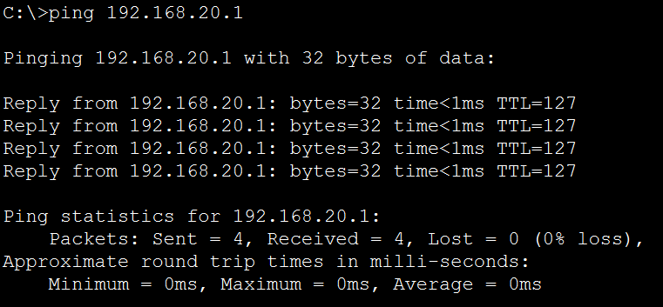
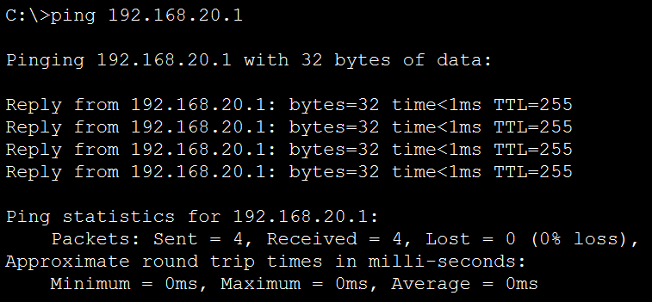

- Web Test: Open browser on any PC → http://www.enterprise.com

Troubleshooting
Step | Command | Purpose
Physical Layer | show ip interface brief | Check interface status and connectivity
VLAN | show vlan brief | Verify VLAN assignment
Trunk | show interfaces trunk | Verify trunking between switch and router
Router-on-a-Stick | show running-config | Confirm subinterfaces and VLAN encapsulation
OSPF | show ip ospf neighbor show ip route | Check OSPF neighbor relationships and routing table
DHCP | show ip dhcp binding | Verify IP leases assigned
DNS | ping www.enterprise.com | Test domain resolution

Discussion
The project demonstrates how a small enterprise network can be segmented into multiple VLANs to improve security and traffic management. Router-on-a-stick provides efficient inter-VLAN routing without requiring multiple physical interfaces. Implementing OSPF ensures dynamic routing and scalability for future expansion. DHCP reduces administrative overhead by automatically assigning IP addresses, while the DNS and web server simulate real-world network services. During the project, VLAN misconfigurations and trunk issues were common challenges, resolved by systematic troubleshooting using show VLAN, show interfaces trunk, and show running-config commands. Proper IP addressing and subnetting are critical to ensure connectivity across VLANs and routers.

Conclusion
This enterprise network project successfully implemented VLAN segmentation for HR and IT departments, inter-VLAN routing using Router-on-a-Stick, dynamic IP assignment via DHCP, and OSPF routing between routers. The DNS and web server configuration allowed seamless access to internal services. Overall, the project provides a clear understanding of designing scalable and secure enterprise networks, demonstrating effective network management and troubleshooting skills in a controlled simulation environment.

